1. Online Library Management System
AIM
To design and develop an Online Library Management System using HTML, CSS, and JavaScript to manage books, student accounts, book issuing and returning, fine calculation, and study materials. The system allows students to search for books, view borrowing history, check fines, download study materials, and manage their profiles. It also provides librarian functionalities to add, update, and delete books and manage library records.
PROCEDURE
- Open Visual Studio Code or any text editor.
- Create a new file named index.html.
- Write the HTML code to design the Online Library Management System.
- Create a navigation menu containing Home, Register, Login, Search Books, Borrow History, Study Materials, My Profile, and Contact.
- Design a book catalog section to display book titles, authors, categories, and availability.
- Create student registration and login forms.
- Add a borrowing history section displaying issue dates, expected return dates, and fine details.
- Create a study materials section to search materials by academic year and semester.
- Design a librarian dashboard to add, update, and delete books and manage issue and return status.
- Add a fine calculation feature based on the number of overdue days.
- Apply CSS styling to make the website attractive and responsive.
- Save the file as index.html and open it in a web browser to test the website.
HTML CODE:

<!DOCTYPE html>
<html lang="en">
<head>
<meta charset="UTF-8">
<meta name="viewport" content="width=device-width, initial-scale=1.0">
<title>Online Library Management System</title>

<style>
* {
box-sizing: border-box;
}

body {
margin: 0;
font-family: Arial, sans-serif;
background: #f1f5f9;
color: #222;
}

header {
background: #17365d;
color: white;
text-align: center;
padding: 22px;
}

nav {
background: #24558a;
text-align: center;
padding: 12px;
}

nav a {
color: white;
text-decoration: none;
margin: 8px;
display: inline-block;
font-weight: bold;
}

.container {
max-width: 1100px;
margin: auto;
padding: 20px;
}

section {
background: white;
padding: 20px;
margin-bottom: 20px;
border-radius: 8px;
box-shadow: 0 2px 7px #d4dce5;
}

h2 {
color: #17365d;
}

input, select, textarea {
width: 100%;
padding: 10px;
margin: 7px 0 12px;
border: 1px solid #bbb;
border-radius: 4px;
}

button {
background: #24558a;
color: white;
border: none;
padding: 10px 16px;
margin: 5px 3px;
border-radius: 4px;
cursor: pointer;
}

button:hover {
background: #17365d;
}

table {
width: 100%;
border-collapse: collapse;
margin-top: 12px;
}

th, td {
border: 1px solid #ccc;
padding: 10px;
text-align: left;
}

th {
background: #e2ebf5;
}

.message {
color: #24558a;
font-weight: bold;
}

footer {
background: #17365d;
color: white;
text-align: center;
padding: 15px;
}

@media (max-width: 600px) {
nav a {
margin: 5px;
}

table {
font-size: 12px;
}

th, td {
padding: 6px;
}
}
</style>
</head>

<body>

<header>
<h1>Online Library Management System</h1>
<p>Search Books, Manage Borrowing and Access Study Materials</p>
</header>

<nav>
<a href="#home">Home</a>
<a href="#register">Register</a>
<a href="#login">Login</a>
<a href="#books">Search Books</a>
<a href="#history">Borrow History</a>
<a href="#materials">Study Materials</a>
<a href="#profile">My Profile</a>
<a href="#admin">Librarian</a>
<a href="#contact">Contact</a>
</nav>

<div class="container">

<section id="home">
<h2>Welcome to the Library</h2>
<p>
This system helps students find books, view availability,
check borrowing details, and access academic materials online.
</p>
</section>

<section id="register">
<h2>Student Registration</h2>
<form onsubmit="registerUser(event)">
<label>Student Name:</label>
<input type="text" id="regName" required>

<label>Email:</label>
<input type="email" id="regEmail" required>

<label>Password:</label>
<input type="password" id="regPassword" required>

<button type="submit">Register</button>
</form>
<p id="registerMessage" class="message"></p>
</section>

<section id="login">
<h2>User Login</h2>
<form onsubmit="loginUser(event)">
<label>Email:</label>
<input type="email" id="loginEmail" required>

<label>Password:</label>
<input type="password" id="loginPassword" required>

<button type="submit">Login</button>
</form>
<p id="loginMessage" class="message"></p>
</section>

<section id="books">
<h2>Search Books</h2>

<input type="text" id="searchBook"
placeholder="Search by book title or author">

<table>
<thead>
<tr>
<th>Book ID</th>
<th>Book Title</th>
<th>Author</th>
<th>Status</th>
<th>Action</th>
</tr>
</thead>
<tbody id="bookList">
<tr>
<td>B101</td>
<td>Introduction to Java</td>
<td>Herbert Schildt</td>
<td>Available</td>
<td>
<button onclick="issueBook('B101')">
Issue Book
</button>
</td>
</tr>
<tr>
<td>B102</td>
<td>Python Programming</td>
<td>John Zelle</td>
<td>Available</td>
<td>
<button onclick="issueBook('B102')">
Issue Book
</button>
</td>
</tr>
<tr>
<td>B103</td>
<td>Data Structures</td>
<td>Mark Allen Weiss</td>
<td>Available</td>
<td>
<button onclick="issueBook('B103')">
Issue Book
</button>
</td>
</tr>
</tbody>
</table>
<p id="bookMessage" class="message"></p>
</section>

<section id="history">
<h2>My Borrow History</h2>

<table>
<thead>
<tr>
<th>Book ID</th>
<th>Issue Date</th>
<th>Expected Return Date</th>
<th>Status</th>
</tr>
</thead>
<tbody id="historyList">
<tr>
<td>B101</td>
<td>2026-10-20</td>
<td>2026-11-03</td>
<td>Issued</td>
</tr>
</tbody>
</table>
</section>

<section id="fine">
<h2>Fine Calculator</h2>

<label>Expected Return Date:</label>
<input type="date" id="dueDate">

<label>Actual Return Date:</label>
<input type="date" id="returnDate">

<label>Fine per overdue day (₹):</label>
<input type="number" id="fineRate" value="5" min="0">

<button onclick="calculateFine()">Calculate Fine</button>
<p id="fineResult" class="message"></p>
</section>

<section id="materials">
<h2>Study Materials</h2>

<label>Academic Year:</label>
<select id="year">
<option value="all">All Years</option>
<option value="1">First Year</option>
<option value="2">Second Year</option>
<option value="3">Third Year</option>
<option value="4">Fourth Year</option>
</select>

<label>Semester:</label>
<select id="semester">
<option value="all">All Semesters</option>
<option value="1">Semester 1</option>
<option value="2">Semester 2</option>
</select>

<button onclick="searchMaterials()">Search Materials</button>

<ul id="materialList">
<li data-year="1" data-semester="1">
First Year - Semester 1 -
<a href="materials/maths.pdf" download>
Mathematics Notes
</a>
</li>
<li data-year="2" data-semester="1">
Second Year - Semester 1 -
<a href="materials/java.pdf" download>
Java Programming Notes
</a>
</li>
<li data-year="3" data-semester="2">
Third Year - Semester 2 -
<a href="materials/ai.pdf" download>
Artificial Intelligence Notes
</a>
</li>
</ul>
<p id="materialMessage" class="message"></p>
</section>

<section id="profile">
<h2>My Profile</h2>
<p id="profileInfo">Register to create a demo profile.</p>
</section>

<section id="admin">
<h2>Librarian Admin Login</h2>

<form onsubmit="adminLogin(event)">
<label>Admin Username:</label>
<input type="text" id="adminName" required>

<label>Password:</label>
<input type="password" id="adminPassword" required>

<button type="submit">Admin Login</button>
</form>

<h3>Manage Books</h3>

<form onsubmit="addBook(event)">
<label>Book ID:</label>
<input type="text" id="newBookId" required>

<label>Book Title:</label>
<input type="text" id="newBookTitle" required>

<label>Author:</label>
<input type="text" id="newBookAuthor" required>

<button type="submit">Add Book</button>
</form>

<label>Book ID to Update or Delete:</label>
<input type="text" id="manageBookId">

<label>New Book Title (for update):</label>
<input type="text" id="updatedTitle">

<button onclick="updateBook()">Update Book</button>
<button onclick="deleteBook()">Delete Book</button>

<h3>Return Book</h3>
<label>Book ID:</label>
<input type="text" id="returnBookId">
<button onclick="returnBook()">Mark as Returned</button>

<p id="adminMessage" class="message"></p>
</section>

<section id="contact">
<h2>Contact Us</h2>
<form onsubmit="contactLibrary(event)">
<label>Name:</label>
<input type="text" required>

<label>Email:</label>
<input type="email" required>

<label>Message:</label>
<textarea rows="4" required></textarea>

<button type="submit">Send Message</button>
</form>
<p id="contactMessage" class="message"></p>
</section>

</div>

<footer>
<p>&copy; 2026 Online Library Management System</p>
</footer>

<script>
let registeredUser = null;

function registerUser(event) {
event.preventDefault();

registeredUser = {
name: document.getElementById("regName").value,
email: document.getElementById("regEmail").value,
password: document.getElementById("regPassword").value
};

document.getElementById("registerMessage").textContent =
"Registration completed for this demo.";

document.getElementById("profileInfo").textContent =
"Name: " + registeredUser.name +
" | Email: " + registeredUser.email;
}

function loginUser(event) {
event.preventDefault();

const email = document.getElementById("loginEmail").value;
const password = document.getElementById("loginPassword").value;

if (registeredUser &&
registeredUser.email === email &&
registeredUser.password === password) {
document.getElementById("loginMessage").textContent =
"Login successful!";
} else {
document.getElementById("loginMessage").textContent =
"Register first or enter the registered details.";
}
}

document.getElementById("searchBook")
.addEventListener("input", function() {
const query = this.value.toLowerCase();

document.querySelectorAll("#bookList tr").forEach(function(row) {
row.style.display =
row.textContent.toLowerCase().includes(query)
? "" : "none";
});
});

function issueBook(id) {
document.getElementById("bookMessage").textContent =
"Issue request recorded for " + id +
" in the demo. Real inventory requires a database.";
}

function calculateFine() {
const due = document.getElementById("dueDate").value;
const returned = document.getElementById("returnDate").value;
const rate = Number(document.getElementById("fineRate").value);

if (!due || !returned || rate < 0) {
document.getElementById("fineResult").textContent =
"Enter valid dates and a non-negative fine rate.";
return;
}

const dueDate = new Date(due + "T00:00:00Z");
const returnDate = new Date(returned + "T00:00:00Z");

const days = Math.max(0,
Math.floor((returnDate - dueDate) / 86400000));

document.getElementById("fineResult").textContent =
"Overdue days: " + days +
" | Total fine: ₹" + (days * rate);
}

function searchMaterials() {
const year = document.getElementById("year").value;
const semester = document.getElementById("semester").value;
let count = 0;

document.querySelectorAll("#materialList li").forEach(function(item) {
const yearMatch =
year === "all" || item.dataset.year === year;
const semesterMatch =
semester === "all" ||
item.dataset.semester === semester;

item.style.display = yearMatch && semesterMatch ? "" : "none";

if (yearMatch && semesterMatch) count++;
});

document.getElementById("materialMessage").textContent =
count + " material(s) found.";
}

function adminLogin(event) {
event.preventDefault();
document.getElementById("adminMessage").textContent =
"Demo admin section opened. Real authentication is required.";
}

function addBook(event) {
event.preventDefault();

const id = document.getElementById("newBookId").value;
const title = document.getElementById("newBookTitle").value;
const author = document.getElementById("newBookAuthor").value;
const tbody = document.getElementById("bookList");

const row = tbody.insertRow();
row.insertCell().textContent = id;
row.insertCell().textContent = title;
row.insertCell().textContent = author;
row.insertCell().textContent = "Available";

const cell = row.insertCell();
const button = document.createElement("button");
button.textContent = "Issue Book";
button.onclick = function() {
issueBook(id);
};
cell.appendChild(button);

document.getElementById("adminMessage").textContent =
"Book added to the current demo page.";
event.target.reset();
}

function updateBook() {
const id = document.getElementById("manageBookId").value;
const title = document.getElementById("updatedTitle").value;
let found = false;

document.querySelectorAll("#bookList tr").forEach(function(row) {
if (row.cells[0].textContent === id && title.trim()) {
row.cells[1].textContent = title;
found = true;
}
});

document.getElementById("adminMessage").textContent =
found ? "Book title updated." : "Book not found or title is empty.";
}

function deleteBook() {
const id = document.getElementById("manageBookId").value;
let found = false;

document.querySelectorAll("#bookList tr").forEach(function(row) {
if (row.cells[0].textContent === id) {
row.remove();
found = true;
}
});

document.getElementById("adminMessage").textContent =
found ? "Book deleted from the demo list." : "Book not found.";
}

function returnBook() {
const id = document.getElementById("returnBookId").value;
let found = false;

document.querySelectorAll("#bookList tr").forEach(function(row) {
if (row.cells[0].textContent === id) {
row.cells[3].textContent = "Available";
found = true;
}
});

document.getElementById("adminMessage").textContent =
found ? "Book marked as returned." : "Book not found.";
}

function contactLibrary(event) {
event.preventDefault();
document.getElementById("contactMessage").textContent =
"Message submitted in the demo.";
}
</script>

</body>
</html>
OUTPUT:
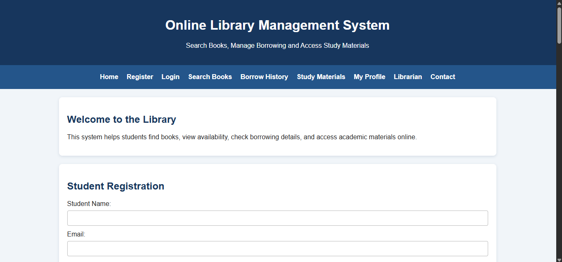
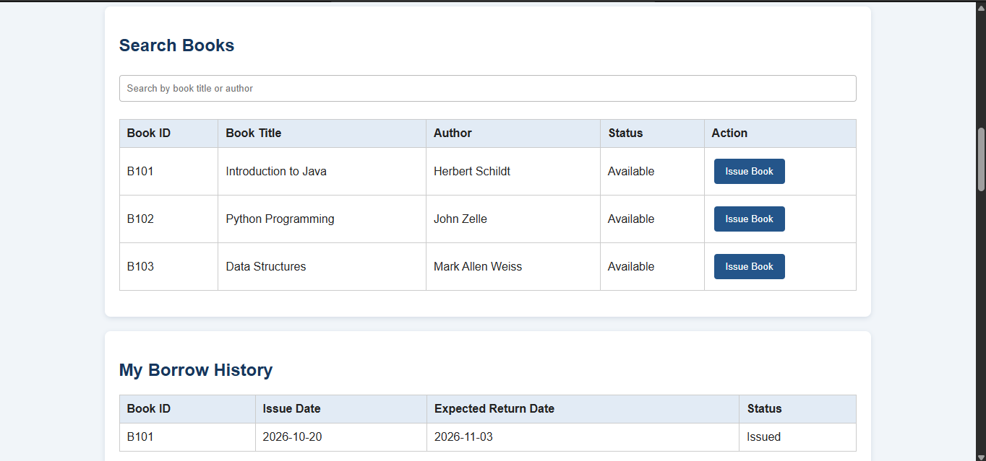
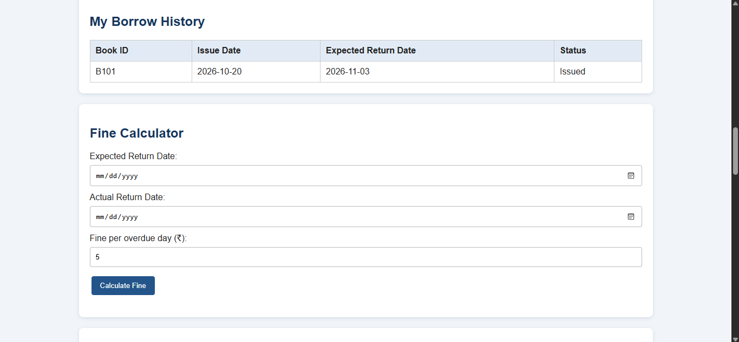

RESULT
Thus, the Online Library Management System was designed successfully using HTML, CSS, and JavaScript. It provides book searching, student registration and login, book issue requests, borrowing history, fine calculation, study material filtering, profile viewing, and librarian functions for adding, updating, and deleting books and marking returns. The responsive interface helps students and librarians access library information conveniently.

